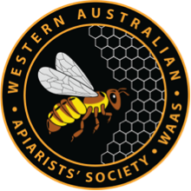
Membership level:
- Family ($65)
- Single ($55)

Date joined_______________
Payment method: Cash* EFT** Card* Cheque***
First Name______________________________________________________
Last Name______________________________________________________
Organisation (if representing)_______________________________________
Email___________________________________________________________
Partners name and email___________________________________________
Phone number – home_____________________________________________
Phone number – mobile____________________________________________
Address_________________________________________________________
________________________________________________________________
Postcode______________
Hive brand_____________
Number of hives_________
Do you have a Flow Hive?__________
*Cash and Card | **EFT | ***Cheque
Payments can only be made at the Perth Monthly Meeting or at Chapter meetings (cash only) | BSB: 302-162  Acct: 1699 870  WA Apiarists Society | Please send to:  WA Apiarists Society  PO Box 224  Bentley WA 6982
Please hand this completed form to the Treasurer or a Committee member at a meeting, email it to membership@waas.org.au or post to
WA Apiarists Society, PO Box 224, Bentley WA 6982

